**Introduction to Open-Source Software**

B. Tech Integrated /Computer / Sem IV

**PART A**

(PART A: TO BE REFFERED BY STUDENTS)

**Experiment No.07**

**A.1—Aim:**

To perform Stream editing operations in Linux.

**A.2--- Prerequisite:**

Theory:

SED command in UNIX stands for stream editor and it can perform lots of functions on file like searching, find and replace, insertion or deletion. Though most common use of SED command in UNIX is for substitution or for find and replace. By using SED you can edit files even without opening them, which is much quicker way to find and replace something in file, than first opening that file in VI Editor and then changing it.

* SED is a powerful text stream editor. Can do insertion, deletion, search and replace(substitution).
* SED command in unix supports regular expression which allows it perform complex pattern matching.

**Syntax:**

**sed OPTIONS... [SCRIPT] [INPUTFILE...]**

**Example:**  
Consider the below text file as an input.

**$cat > happyfile.txt**

unix is great os. unix is opensource. unix is free os.

learn operating system.

unix linux which one you choose.

unix is easy to learn.unix is a multiuser os.Learn unix .unix is a powerful.

**Sample Commands**

1. **Replacing or substituting string :** Sed command is mostly used to replace the text in a file. The below simple sed command replaces the word “unix” with “linux” in the file.
2. **$sed 's/unix/linux/' happyfile.txt**

**Output :**

linux is great os. unix is opensource. unix is free os.

learn operating system.

linux linux which one you choose.

linux is easy to learn.unix is a multiuser os.Learn unix .unix is a powerful.

Here the “s” specifies the substitution operation. The “/” are delimiters. The “unix” is the search pattern and the “linux” is the replacement string.

By default, the sed command replaces the first occurrence of the pattern in each line and it won’t replace the second, third…occurrence in the line.

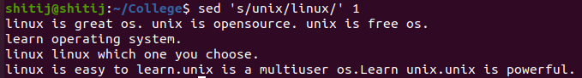

1. **Replacing the nth occurrence of a pattern in a line :** Use the /1, /2 etc flags to replace the first, second occurrence of a pattern in a line. The below command replaces the second occurrence of the word “unix” with “linux” in a line.
2. **$sed 's/unix/linux/2' happyfile.txt**

**Output:**

unix is great os. linux is opensource. unix is free os.

learn operating system.

unix linux which one you choose.

unix is easy to learn.linux is a multiuser os.Learn unix .unix is a powerful.

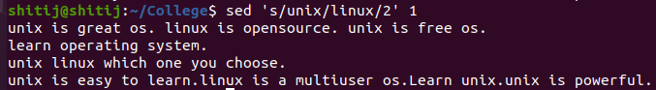

1. **Replacing all the occurrence of the pattern in a line :**The substitute flag /g (global replacement) specifies the sed command to replace all the occurrences of the string in the line.
2. **$sed 's/unix/linux/g' happyfile.txt**

**Output :**

linux is great os. linux is opensource. linux is free os.

learn operating system.

linux linux which one you choose.

linux is easy to learn.linux is a multiuser os.Learn linux .linux is a powerful.

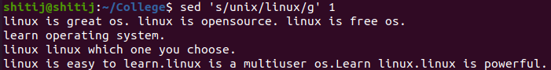

1. **Replacing from nth occurrence to all occurrences in a line :**Use the combination of /1, /2 etc and /g to replace all the patterns from the nth occurrence of a pattern in a line. The following sed command replaces the third, fourth, fifth… “unix” word with “linux” word in a line.
2. **$sed 's/unix/linux/3g' happyfile.txt**

**Output:**

unix is great os. unix is opensource. linux is free os.

learn operating system.

unix linux which one you choose.

unix is easy to learn.unix is a multiuser os.Learn linux .linux is a powerful.

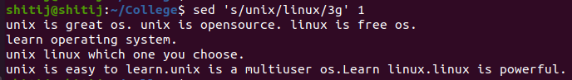

1. **Parenthesize first character of each word :**This sed example prints the first character of every word in parenthesis.
2. **$ echo "Welcome To The Happy Stuff" | sed 's/\(\b[A-Z]\)/\(\1\)/g'**

Output:

(W)elcome (T)o (T)he (G)eek (S)tuff



1. **Replacing string on a specific line number :**You can restrict the sed command to replace the string on a specific line number. An example is
2. **$sed '3 s/unix/linux/' happyfile.txt**

**Output:**

unix is great os. unix is opensource. unix is free os.

learn operating system.

linux linux which one you choose.

unix is easy to learn.unix is a multiuser os.Learn unix .unix is a powerful.

The above sed command replaces the string only on the third line.

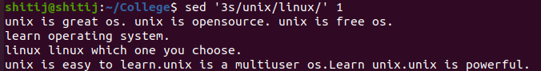

1. **Duplicating the replaced line with /p flag :**The /p print flag prints the replaced line twice on the terminal. If a line does not have the search pattern and is not replaced, then the /p prints that line only once.
2. **$sed 's/unix/linux/p' happyfile.txt**

**Output:**

linux is great os. unix is opensource. unix is free os.

linux is great os. unix is opensource. unix is free os.

learn operating system.

linux linux which one you choose.

linux linux which one you choose.

linux is easy to learn.unix is a multiuser os.Learn unix .unix is a powerful.

linux is easy to learn.unix is a multiuser os.Learn unix .unix is a powerful.

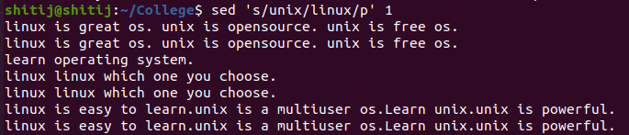

1. **Printing only the replaced lines :**Use the -n option along with the /p print flag to display only the replaced lines. Here the -n option suppresses the duplicate rows generated by the /p flag and prints the replaced lines only one time.
2. **$sed -n 's/unix/linux/p' happyfile.txt**

**Output:**

linux is great os. unix is opensource. unix is free os.

linux linux which one you choose.

linux is easy to learn.unix is a multiuser os.Learn unix .unix is a powerful.

If you use -n alone without /p, then the sed does not print anything.

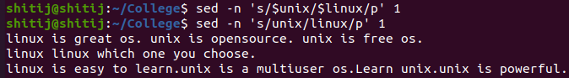

1. **Replacing string on a range of lines :** You can specify a range of line numbers to the sed command for replacing a string.
2. **$sed '1,3 s/unix/linux/' happyfile.txt**

**Output:**

linux is great os. unix is opensource. unix is free os.

learn operating system.

linux linux which one you choose.

unix is easy to learn.unix is a multiuser os.Learn unix .unix is a powerful.

Here the sed command replaces the lines with range from 1 to 3. Another example is

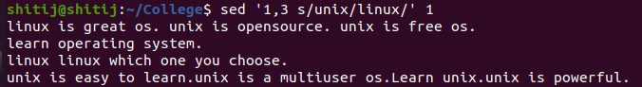

**$sed '2,$ s/unix/linux/' happyfile.txt**

**Output:**

unix is great os. unix is opensource. unix is free os.

learn operating system.

linux linux which one you choose.

linux is easy to learn.unix is a multiuser os.Learn unix .unix is a powerful

Here $ indicates the last line in the file. So the sed command replaces the text from second line to last line in the file.

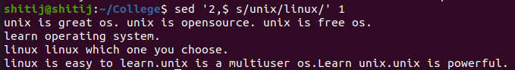

1. **Deleting lines from a particular file :** SED command can also be used for deleting lines from a particular file. SED command is used for performing deletion operation without even opening the file  
   Examples:  
   1. To Delete a particular line say n in this example
2. Syntax:
3. $ sed 'nd' filename.txt
4. Example:
5. $ sed '5d' filename.txt

2. To Delete a last line

Syntax:

$ sed '$d' filename.txt

3. To Delete line from range x to y

Syntax:

$ sed 'x,yd' filename.txt

Example:

$ sed '3,6d' filename.txt

4. To Delete from nth to last line

Syntax:

$ sed 'nth,$d' filename.txt

Example:

$ sed '12,$d' filename.txt

5. To Delete pattern matching line

Syntax:

$ sed '/pattern/d' filename.txt

Example:

$ sed '/abc/d' filename.txt

We humans are certainly an intelligent species. We work with others and we depend on each other for common tasks. For example, you depend on a milkman to deliver milk in milk bottles or cartons. This logic applies to computer programs including shell scripts. When scripts gets complex you need to use divide and conquer technique.

Shell functions

* Sometime shell scripts get complicated.
* To avoid large and complicated scripts use functions.
* You divide large scripts into a small chunks/entities called functions.
* Functions makes shell script modular and easy to use.
* Function avoids repetitive code. For example, is_root_user () function can be reused by various shell scripts to
* determine whether logged on user is root or not.
* Function performs a specific task. For example, add or delete a user account.
* Function used like normal command.
* In other high level programming languages function is also known as procedure, method, subroutine, or routine.

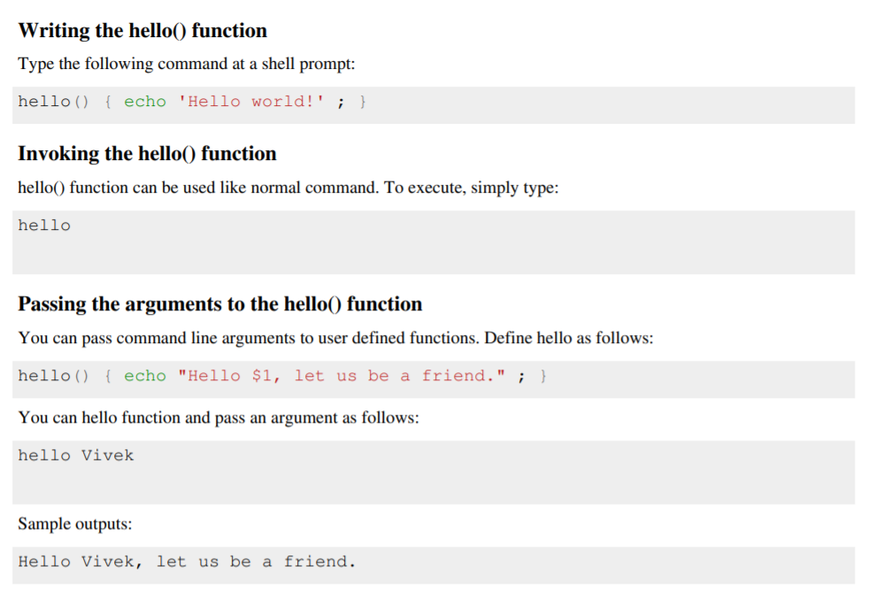

**A.3--- Tasks:**

1. Write a Shell script that accepts a filename, starting and ending line numbers as arguments and displays the lines between the given line numbers.

2. Write a Shell script that displays list of all the files in the current directory to which the user has read, Write and execute permissions.

**(PART - B)**

(TO BE COMPLETED BY STUDENTS)

(Students must submit the soft copy as per following segments within two hours of the practical.

The soft copy must be uploaded on the Blackboard or emailed to the concerned lab in charge faculties at the end of the practical in case there is no Black board access available)

|  |  |
| --- | --- |
| Roll.No.: C020 | Name: Shitij Agrawal |
| Sem/Year: Sem IV | Batch: B1 |
| Date of Experiment: 08/02/2022 | Date of Submission: 08/02/2022 |
| Grade -- |  |

# B.1: Procedure of performed experiment

1. Write a Shell script that accepts a filename, starting and ending line numbers as arguments and displays the lines between the given line numbers.

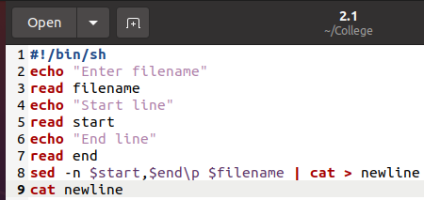

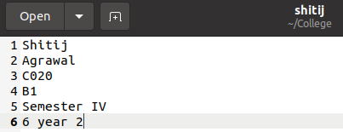

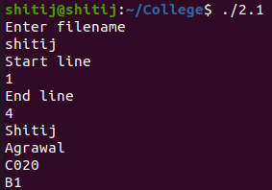

2. Write a Shell script that displays list of all the files in the current directory to which the user has read, Write and execute permissions.

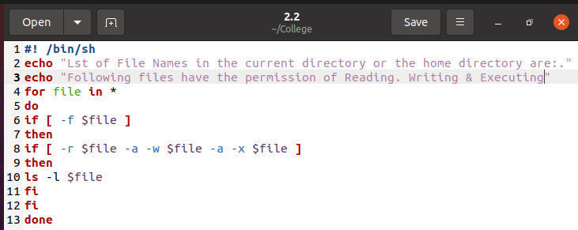

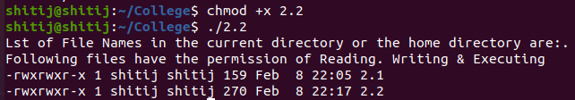

# B.2: Observations and Learning’s:

Learned how to use different string functions in shell (i.e how to change one string from one to another, deleting strings, etc). Also learned how to access files in the directory from the terminal.

# B.3: Conclusion:

Performing Stream editing operations in Linux.